1. Change all the variables so there is no my_ in front of each one. Make sure you change the name everywhere, not just where you used = to set them.

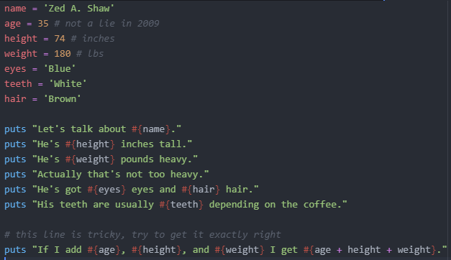

Ouput:

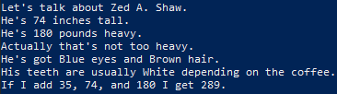

1. Try to write some variables that convert the inches and pounds to centimeters and kilograms. Do not just type in the measurements. Work out the math in Ruby.

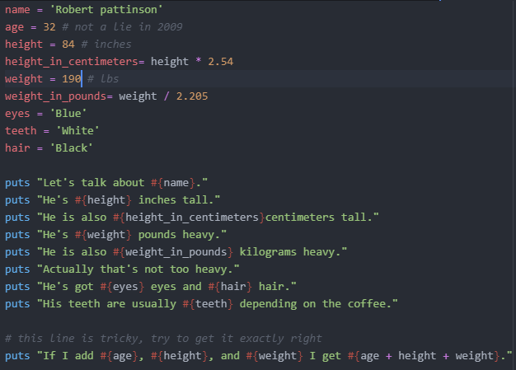

Output:

